

Large-Scale and Multi-Structure Database

Reviook  
User Manual

Application developed by  
Arancio Febbo Salvatore, Di Donato Mattia, Giorgi Matteo

Contents

Application Guide 4

Login Page 5

Registration Page 6

Author’s Page 7

To read 7

Read 8

Published 9

Follow 10

Follower 11

Home Functionalities 12

Update Page 13

New Book 14

Ranking 15

Annual Publications 15

Most Reliable Users 16

Most Popular Books 17

Most Desired Books 18

Research Books 19

Book’s Page 20

How to add a new review 21

View review 22

Research Authors 23

Research Users 24

User’s Page 25

Admin’s Page 26

Deletion recovery 27

Search for users and authors 28

Books reported 29

Reviews reported 30

# Application Guide

This document shows the application’s functionalities.

The database is located on the servers of the University of Pisa and connected via VPN.

In this application, three types of users with different privileges can log in.   
There is the normal user, the author and the admin.

Each individual user role will be explained below using credentials taken to test.

|  |  |  |
| --- | --- | --- |
| TYPE OF ACCOUNT | USRNAME | PASSWORD |
| Admin account | MattiaDiDonato | MattiaDiDonato2022 |
| User account | SalvatoreArancio | SalvatoreArancio2022 |
| Author account | MatteoGiorgi | MatteoGiorgi2022 |

# Login Page

Allows you to select author, user or admin

Switch to SingUp page

Switch to Login page

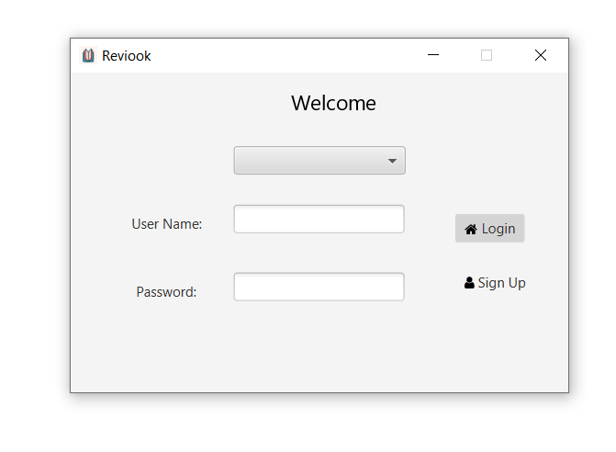

# Registration Page

Fill in all fields to record

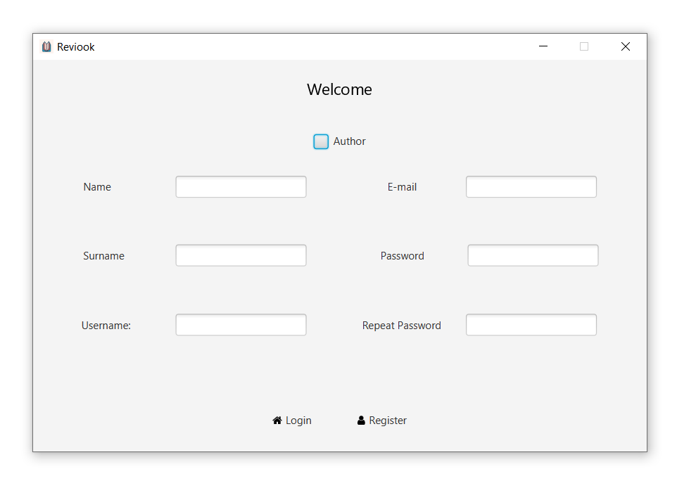

# Author’s Page

Here you can view the books that an author wants to read

## To read

Suggested users based on the books that are in the "to read" and "read" sections

Suggested Authors based on the books that are in the "to read" and "read" sections

Average of reviews based on the genre of the books written by the author

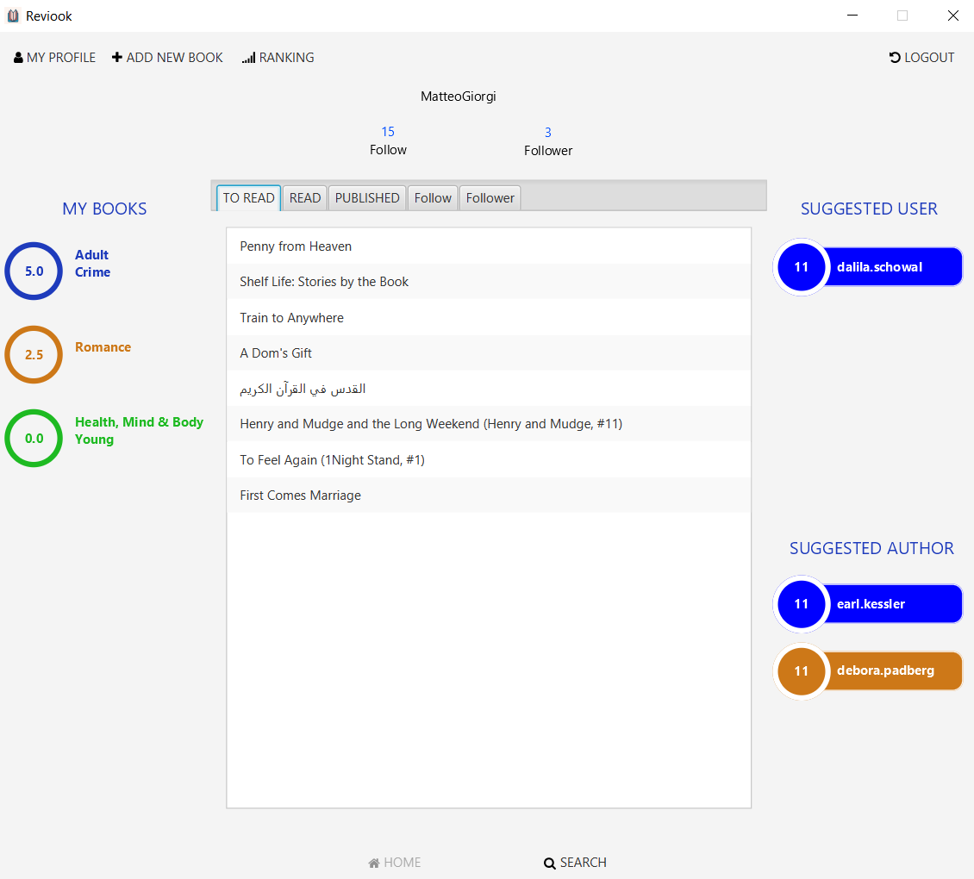

## Read

You can see the books that an author has read

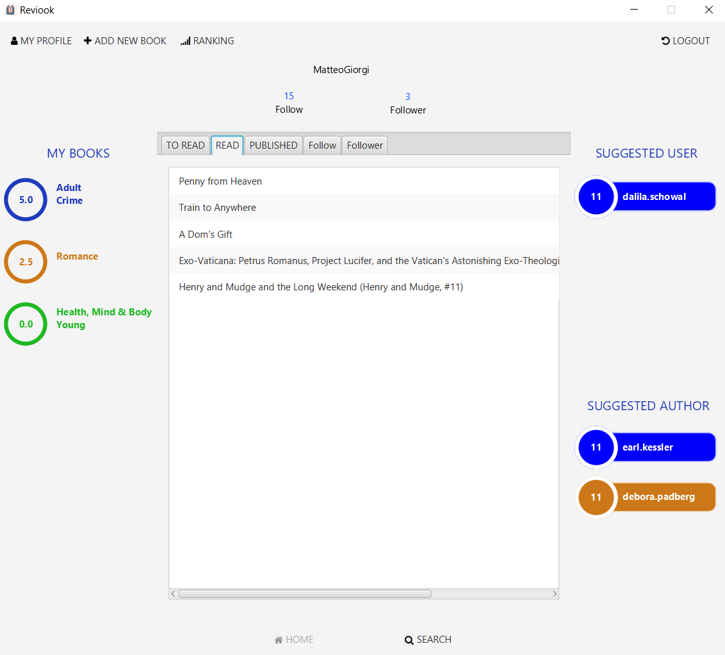

## Published

You can see the books that an author has published

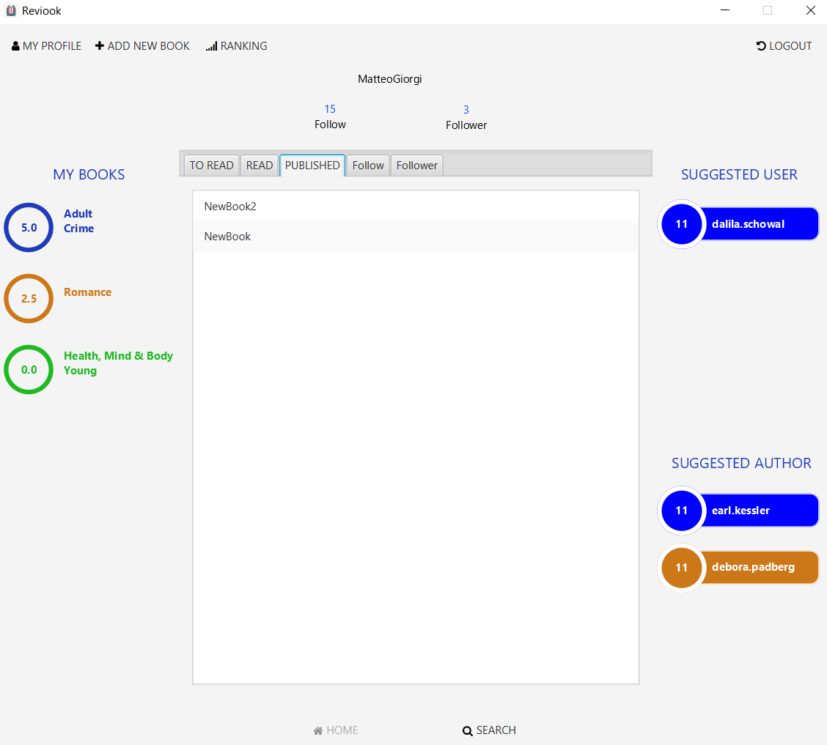

## Follow

You can see the users / authors that an author follows

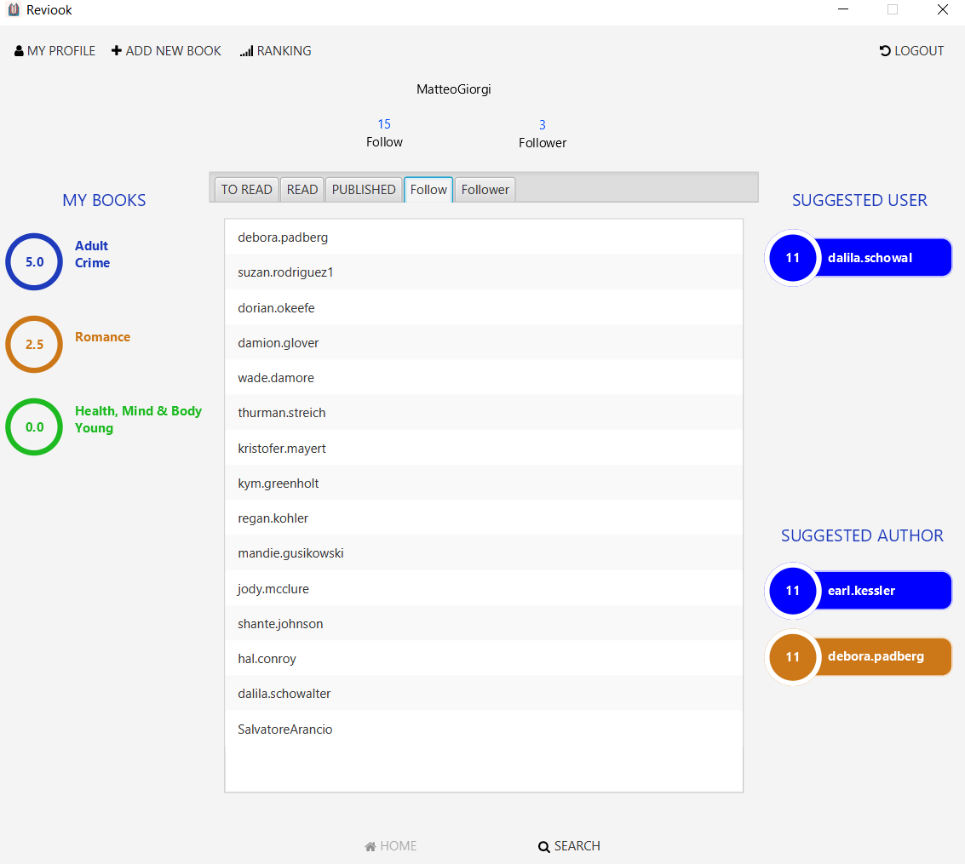

## Follower

You can see users / authors following an author

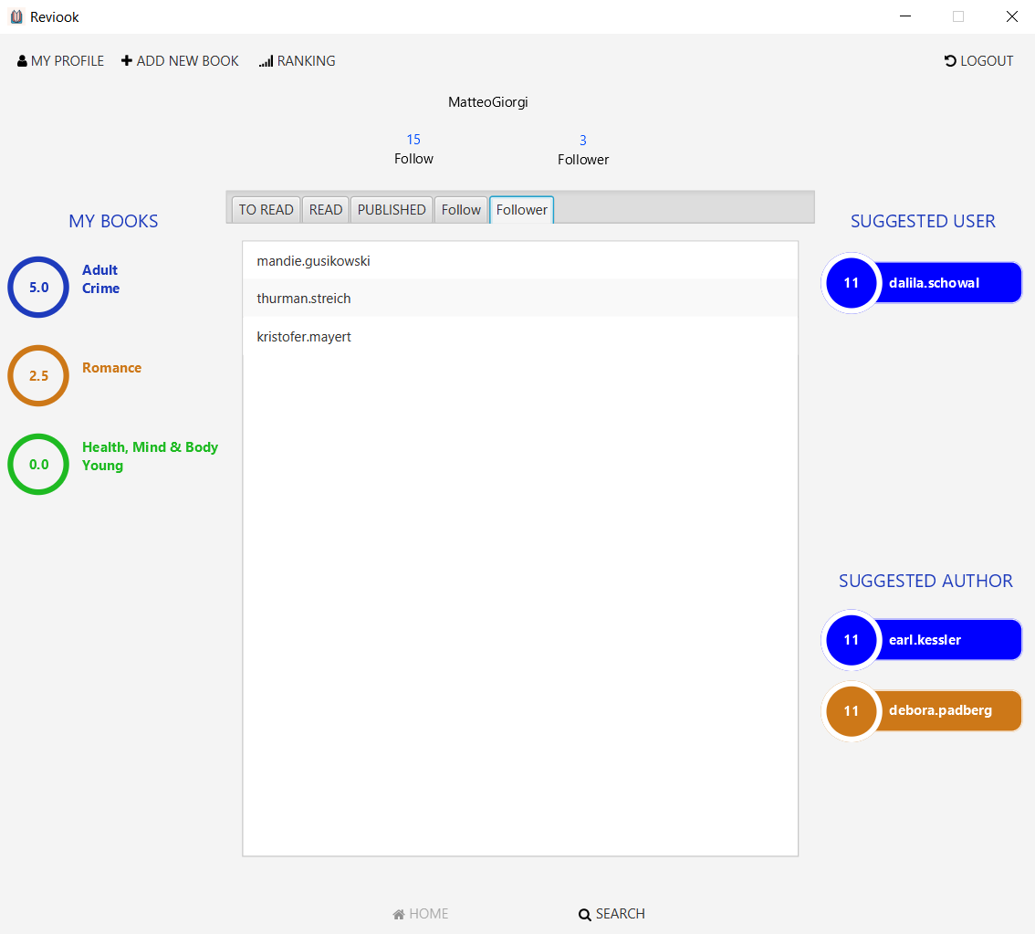

# Home Functionalities

By clicking here, you have access to the following described three functionalities

# Update Page

You can update your password

You can delete your account

# New Book

Fill in all the fields to insert a new book

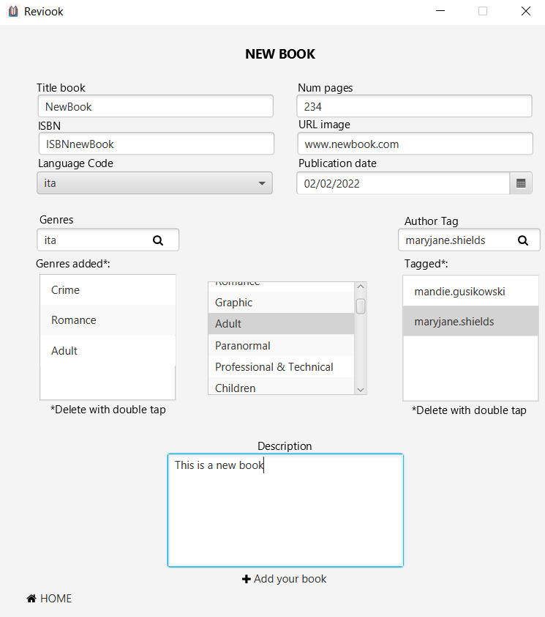

# Ranking

## Annual Publications

Shows how many books have been published by genre for the selected year

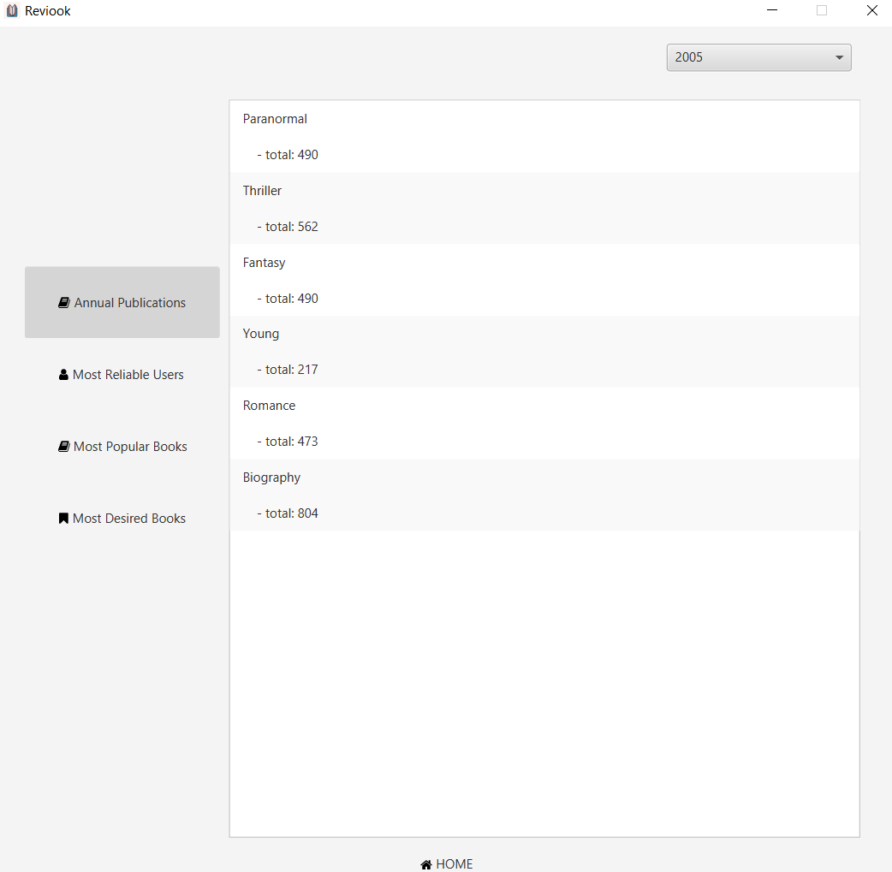

## Most Reliable Users

Ranking of users based on reviews and helpful ratings received

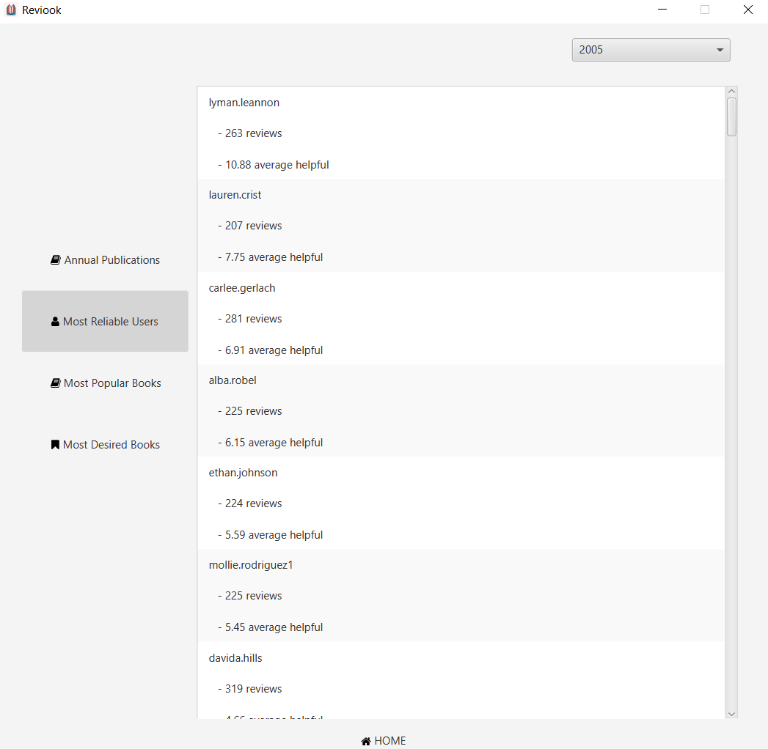

## Most Popular Books

Ranking of books based on how many users have read that book

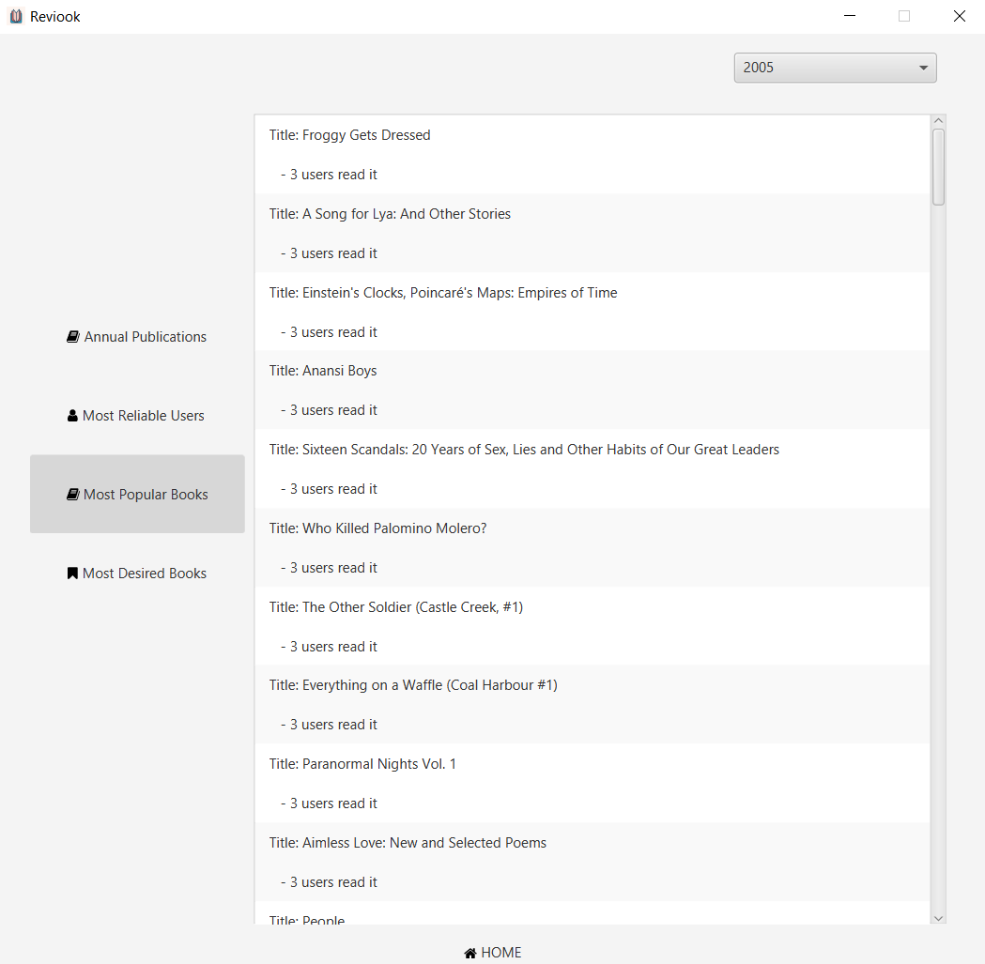

## Most Desired Books

Ranking of books based on how many users would like to read a particular book

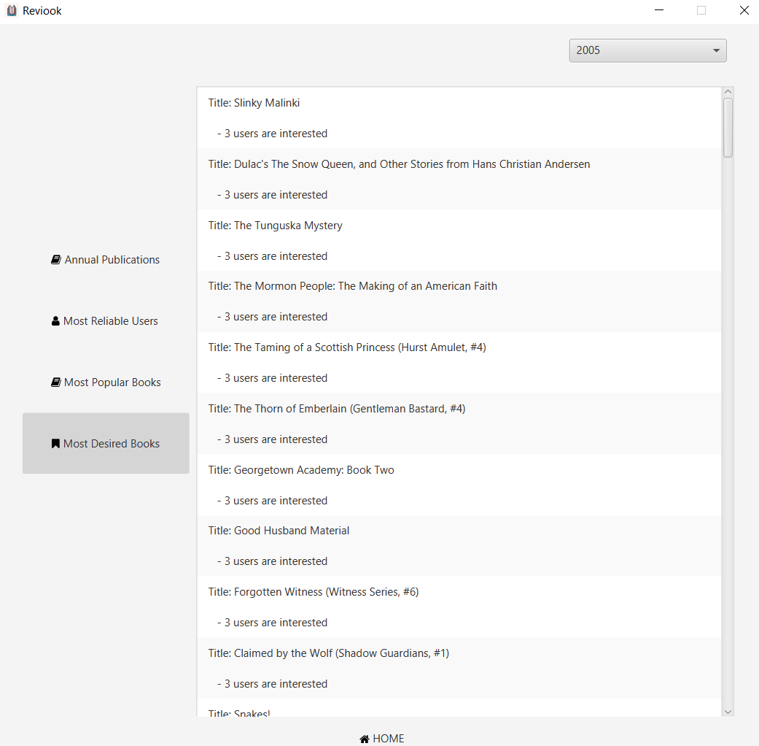

# Research Books

It is also possible to search a book by category, or by title within a category

Shows the books searched by title

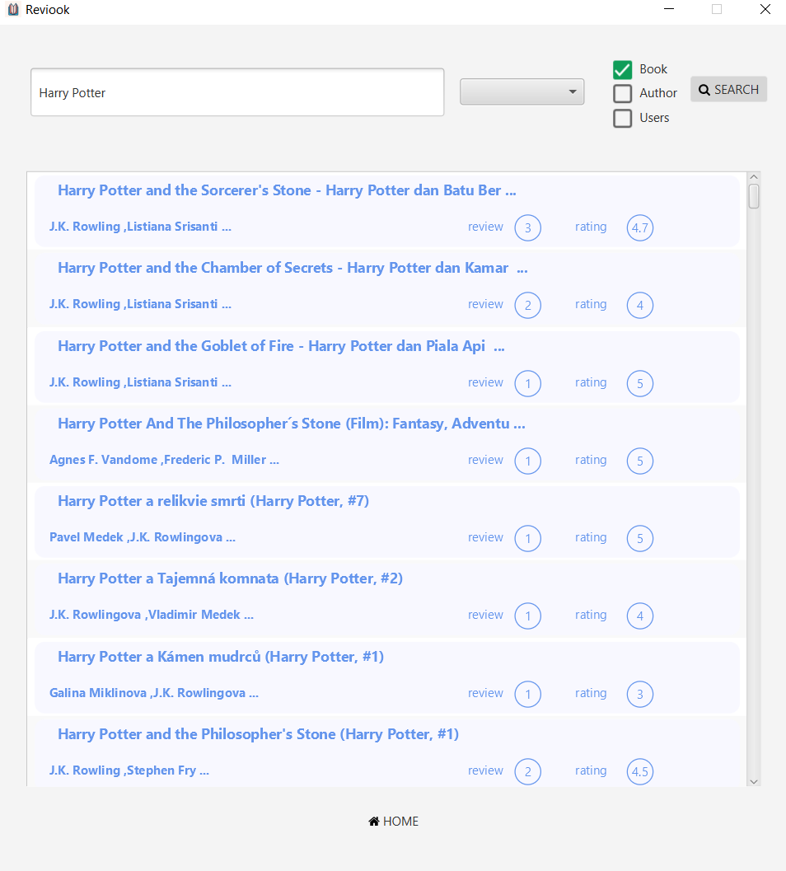

# Book’s Page

You can report a review after selecting it

You can add this book to your read or to_read list of books

You can report a book

Shows reviews of a book

Suggested authors based on a relationship of co-authoring on another book

Suggested Books based on other author’s works

## How to add a new review

You are also able to edit or delete your own review, after selecting it in the list and clicking on the proper button

We can enter a review and a rating ranging from 0 to 5

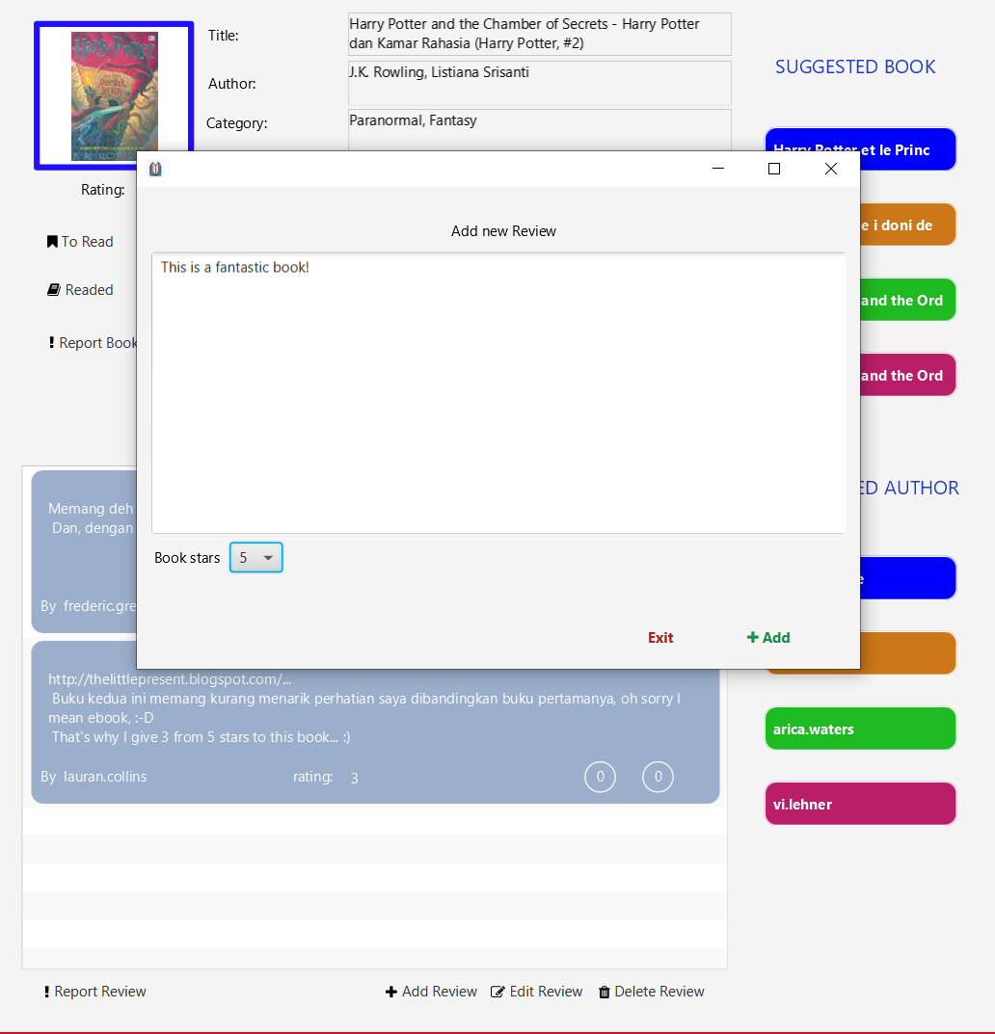

## View review

Show full reviews

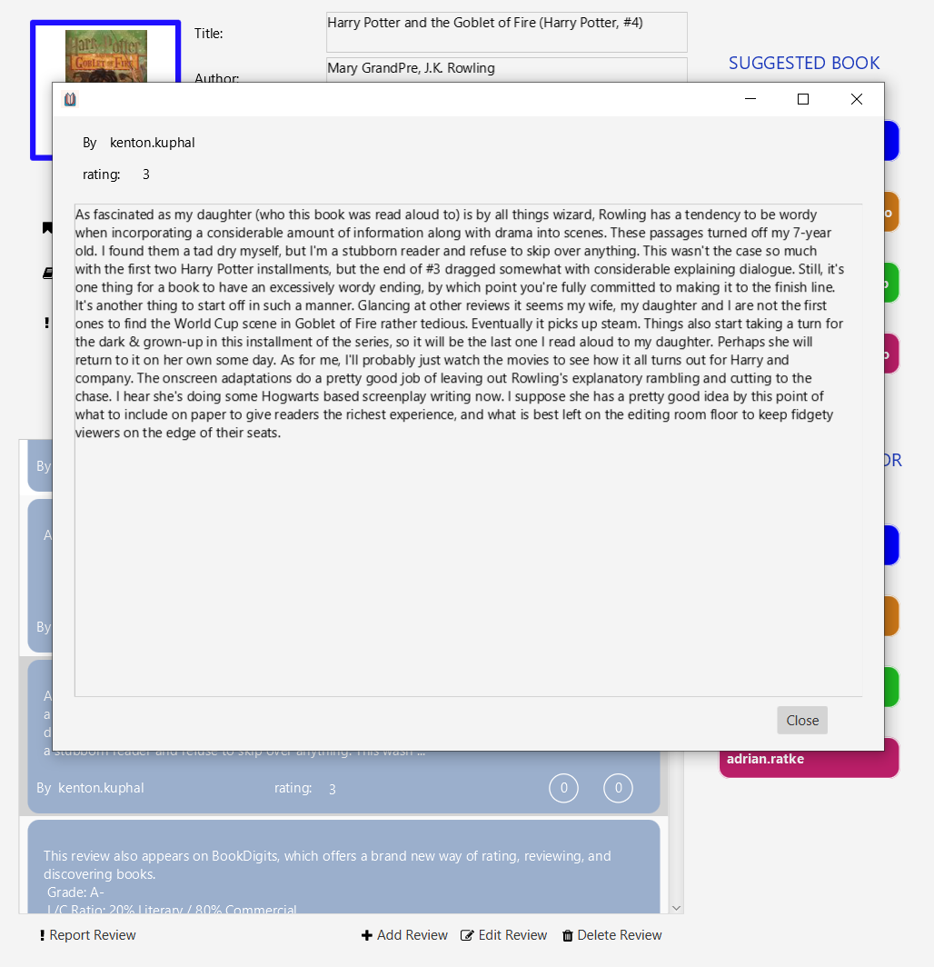

# Research Authors

You can search authors by username and name

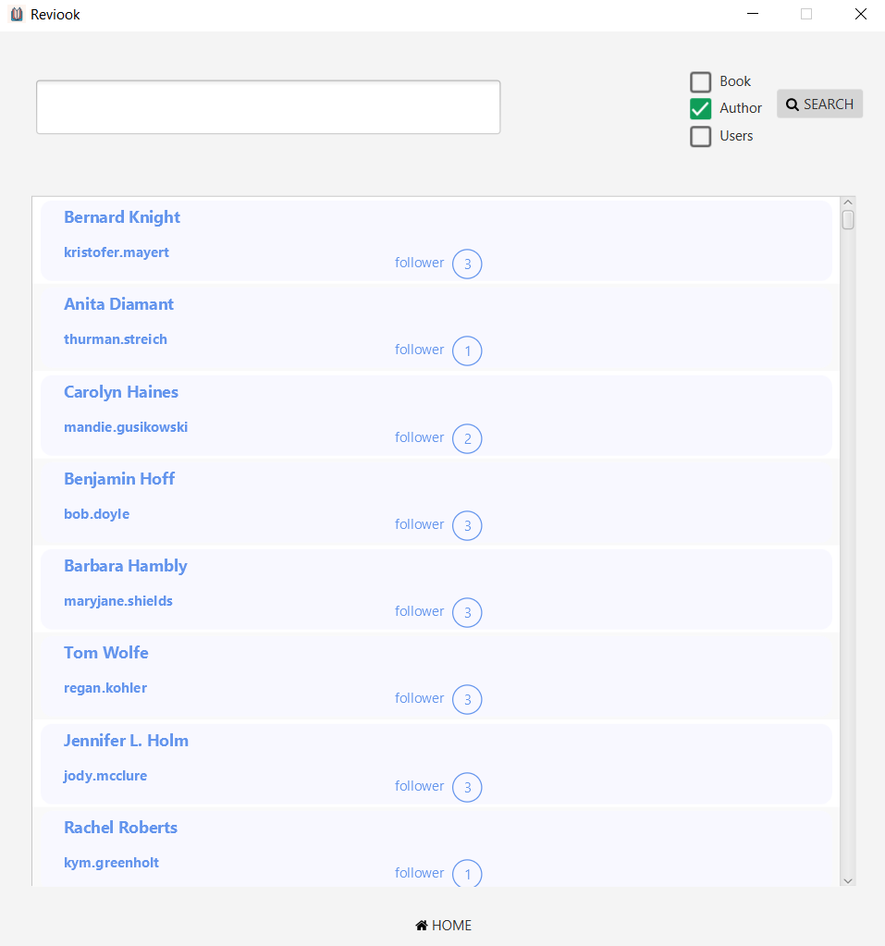

# Research Users

Shows the users searched by username and name

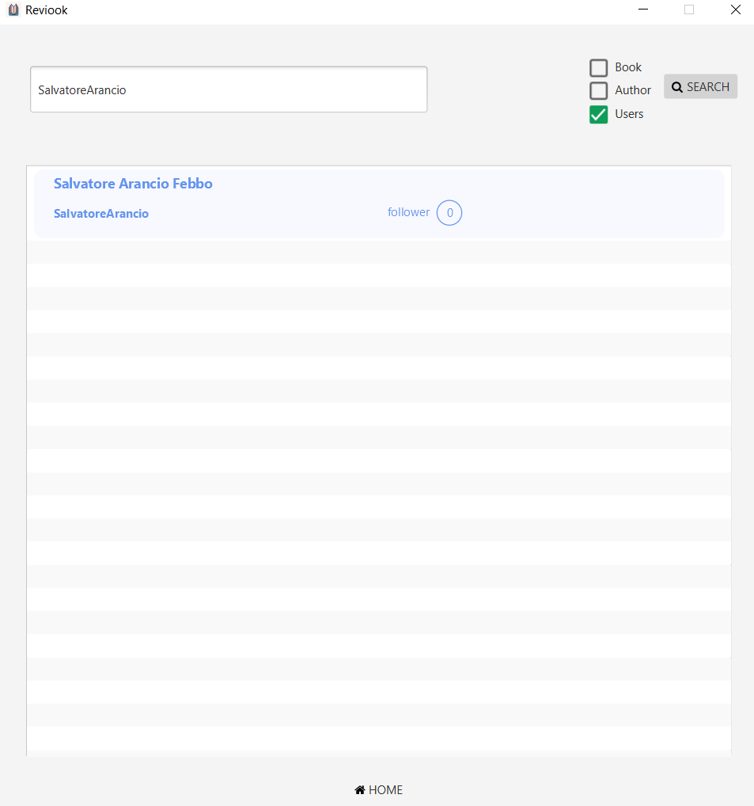

# User’s Page

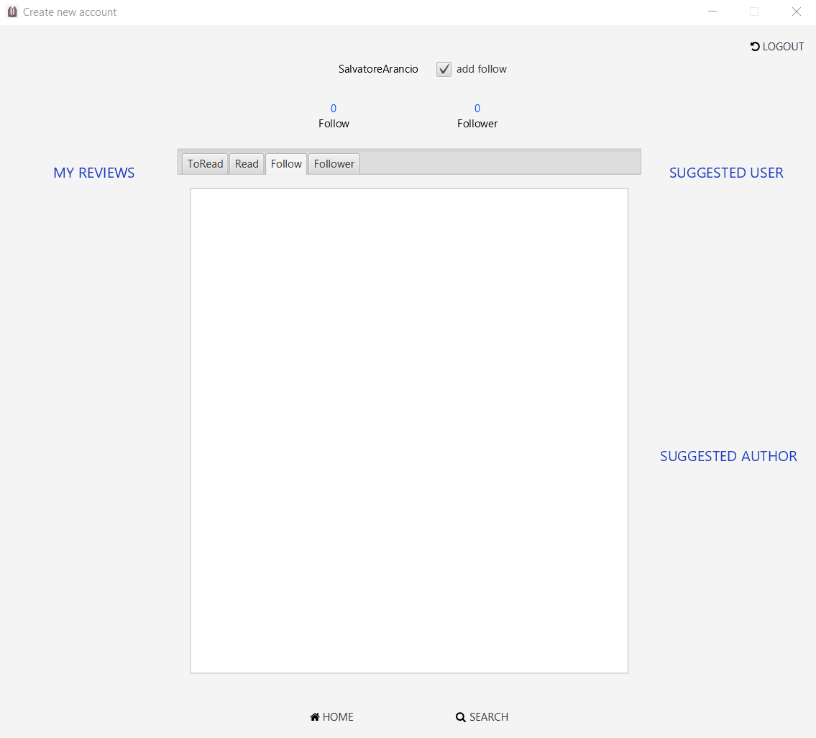

# Admin’s Page

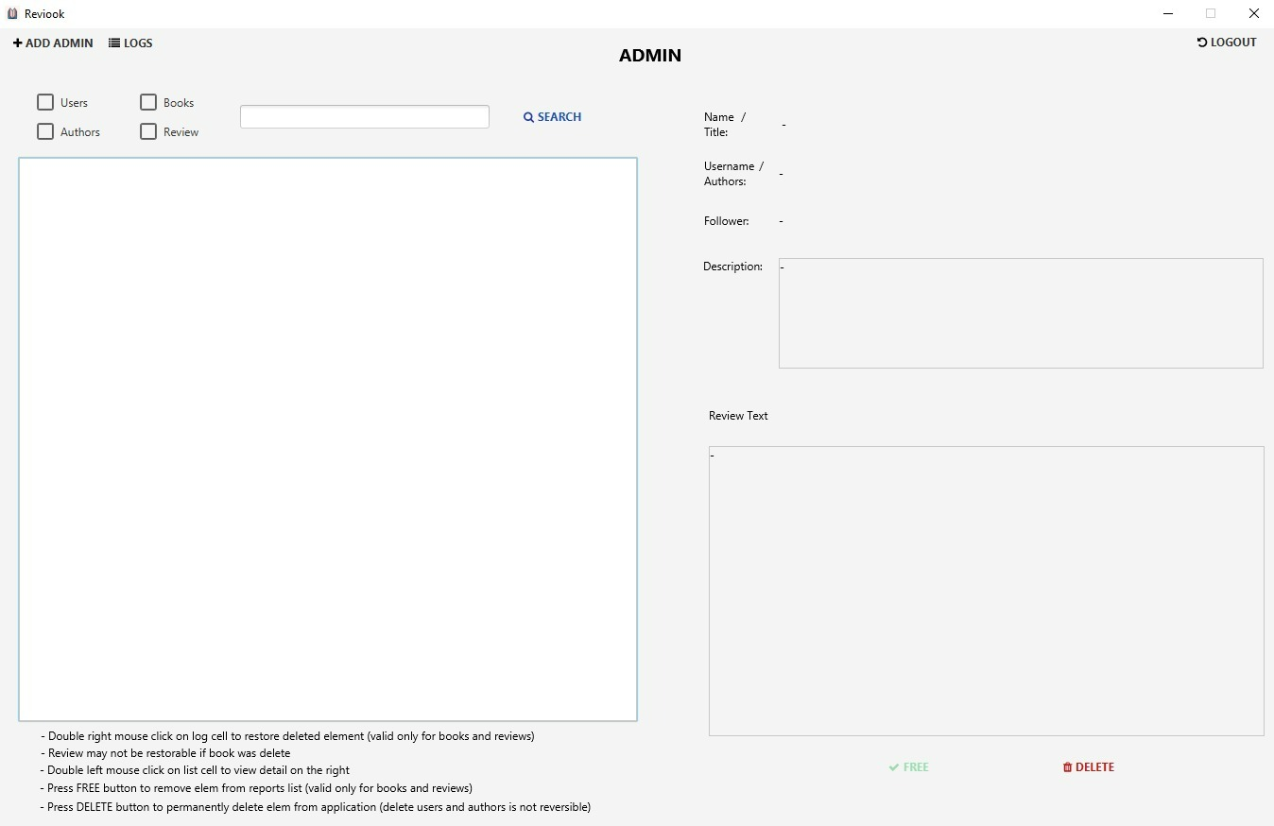

Records the de-reporting and deletion of books and reviews carried out by the admin

## Deletion recovery

An admin can also create a profile for another administrator

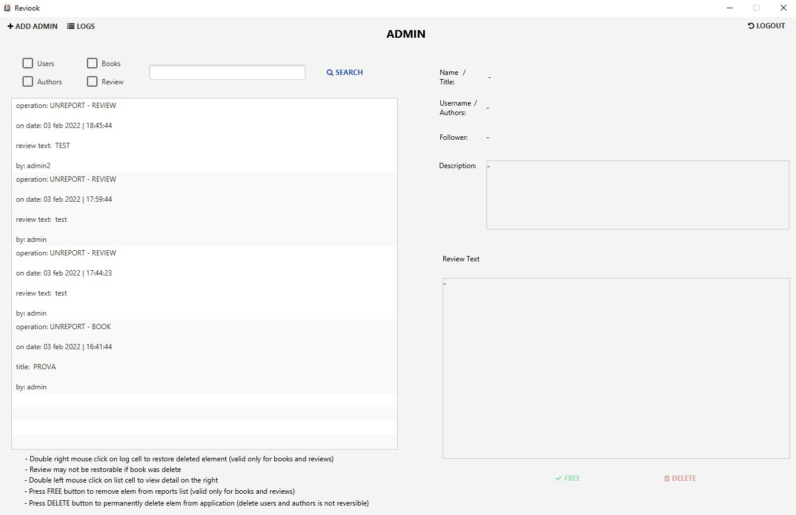

## Search for users and authors

Shows the users/authors who can be deleted

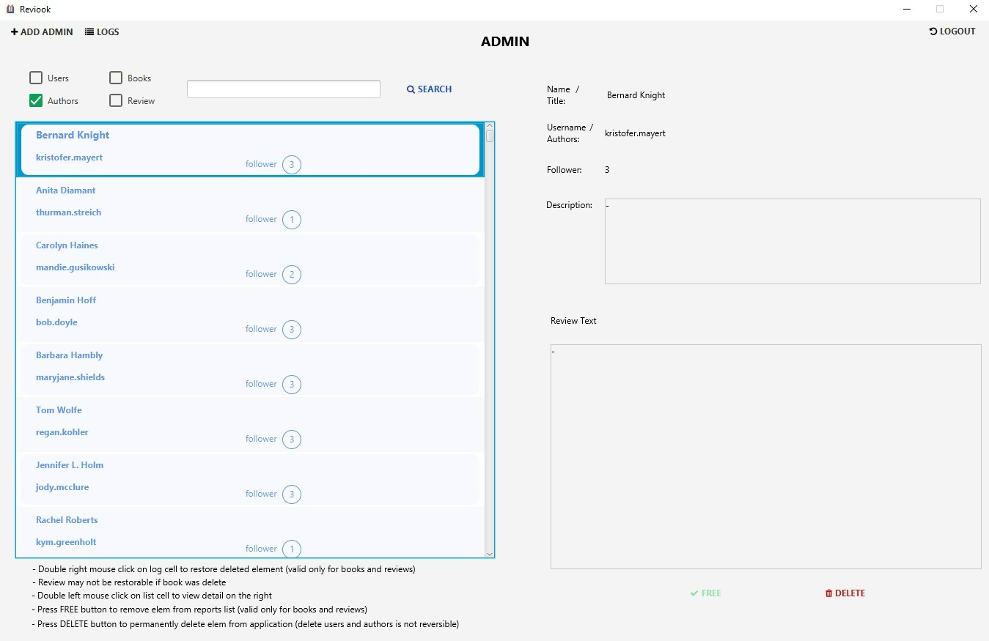

## Books reported

Shows the reported books

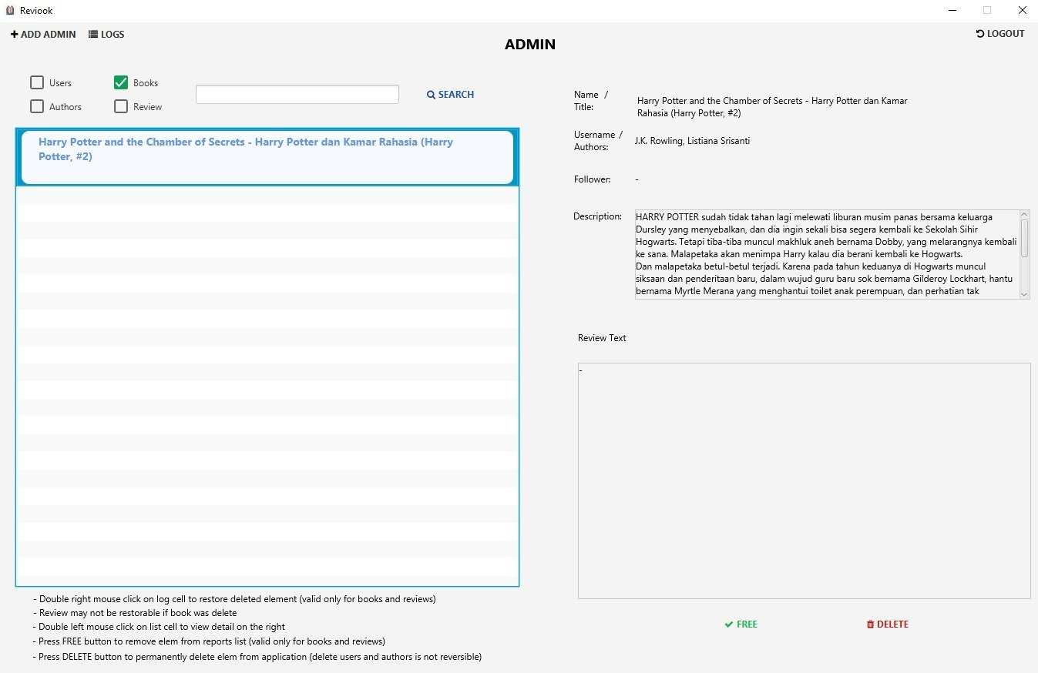

## Reviews reported

Shows the reported reviews

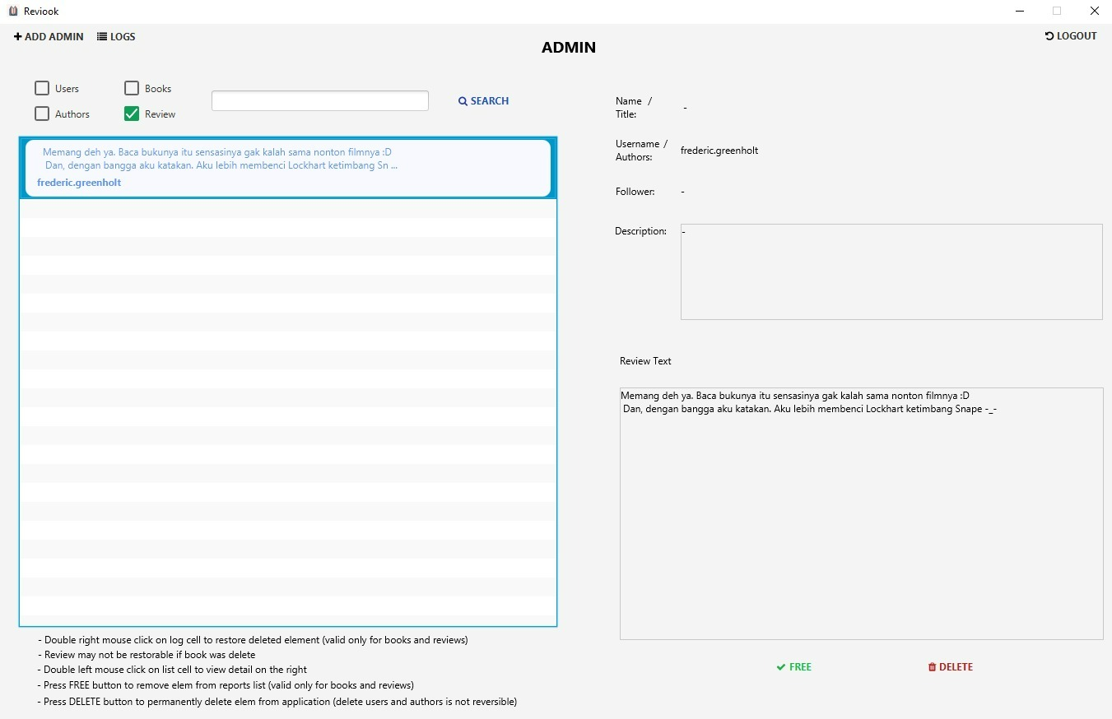

After selecting a reported review/book you can decide to remove the report (FREE) or delete the review/book (DELETE)